FAUQUIER COUNTY WATER AND SANITATION AUTHORITY

AS-BUILT SURVEY SERVICES
Contract No. 17-P-99-0215
NOTICE OF AWARD
July 26, 2017
A. Morton Thomas & Associates, Inc.
Attention: Daniel Schriever, Prof. LS
800 King Farm Blvd, Fourth Floor
Rockville, MD 20850
Project Description: As-Built Survey Services
The Fauquier County Water and Sanitation Authority (the "Owner") has considered the Proposal submitted by you for the above-described Work in response to its Request for Proposals.
You are hereby notified that your Proposal has been accepted by the Owner.
You are required to furnish the Certificates of Insurance as referenced in Section 5.2 of the Contract within thirty (30) days of the commencement of any Services under this
If you fail to execute said Professional Services Agreement the Owner will be entitled to consider all your rights arising out of the Owner's acceptance of your Proposal as abandoned. The Owner additionally will be entitled to exercise such other rights and remedies as may be granted by law. You are reminded that you may not begin action under this contract until you have received a related Task Order.
You are required to return an acknowledged copy of this Notice of Award to the Owner.
Dated this 26th day of July 2017.
OWNER:
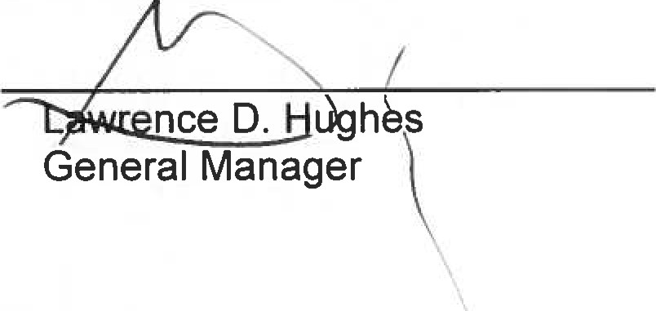
SANITATION
AUTHORITY
FAUQUIER
COUNTY
WATER
AND
By:

ACKNOWLEDGEMENT OF NOTICE OF AWARD
Acceptance of the above Notice of Award is hereby acknowledged by thisday of August 2017:
LAND SURVEYOR:
A. MORTON THOMAS & ASSOCIATES, INC.
By:

